Exercise 3 – Stored Procedures

Scenario 1 – ProcessMonthlyInterest

Objective
Calculate and update the balance of all Savings accounts by applying 1% monthly interest.
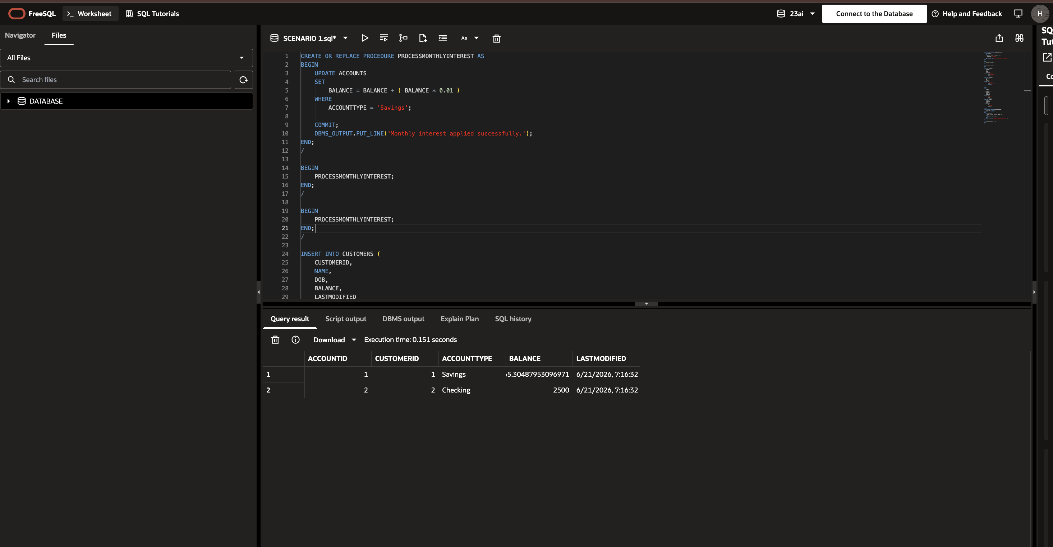

Scenario 2 – UpdateEmployeeBonus

Objective
Update the salary of employees in a given department by adding a bonus percentage passed as a parameter.
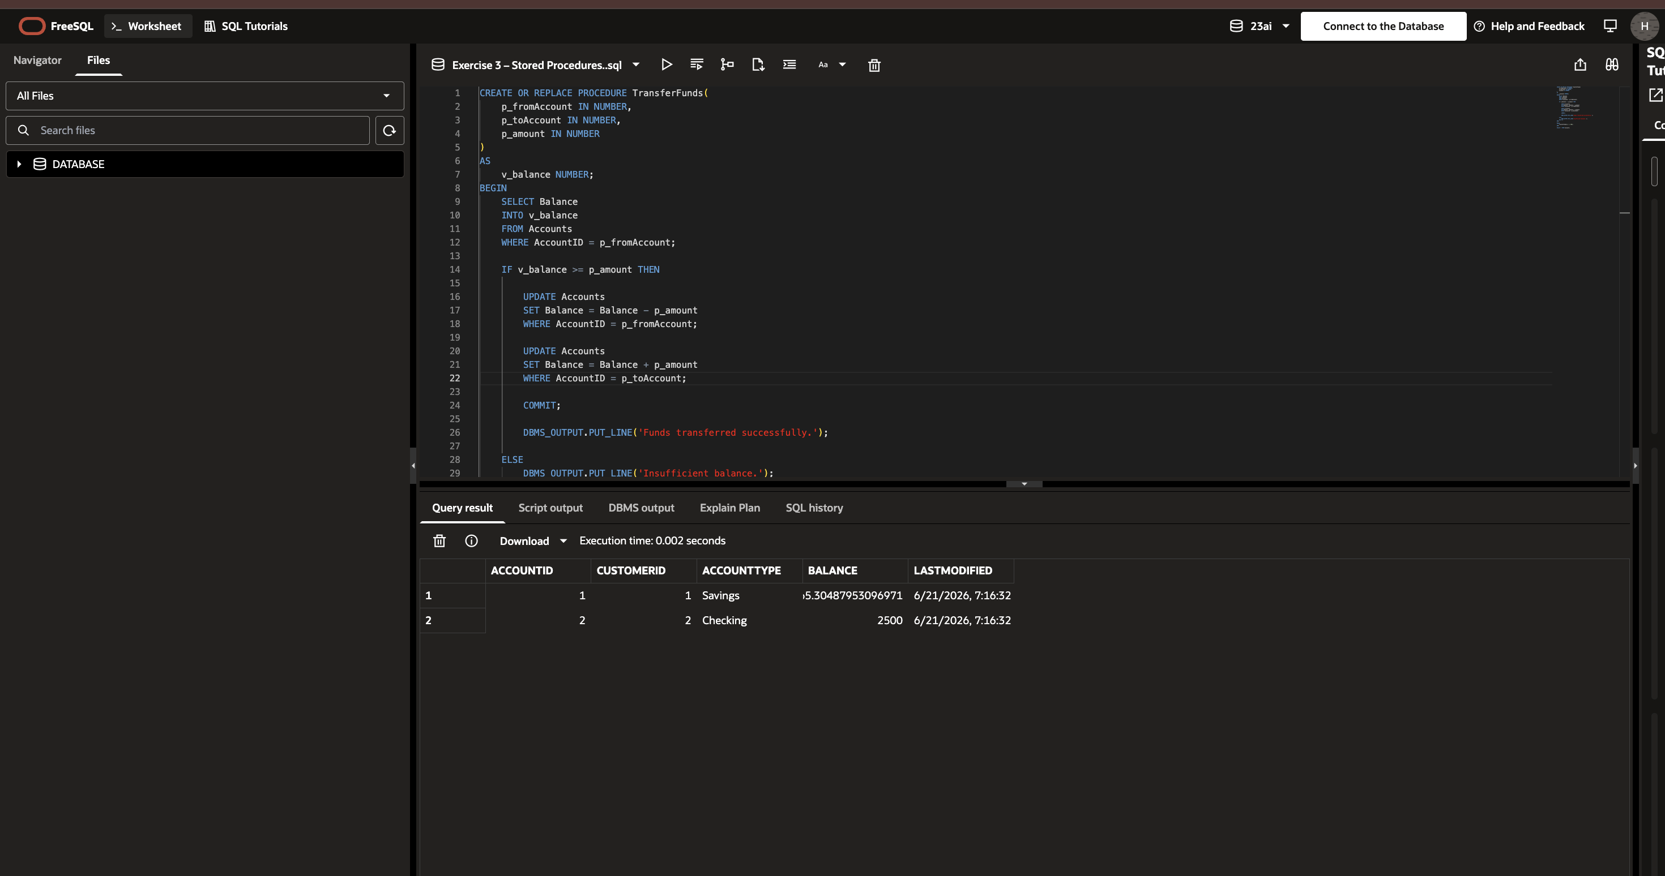

Scenario 3 – TransferFunds

Objective
Transfer money from one account to another after checking that the source account has sufficient balance.

